Query Engine
Prerequisite reading:
- QueryObject_Design.doc
- caGrid-1.0 Programmer’s guide (Chapter 5. caGrid data services)

Overview:
The category constraints made by the user using the caB2B client’s DAG view are stored in the query-object i.e. ICab2bQuery (which extends IQuery to add information regarding output class’ service urls). The query engine is an EJB that processes the ICab2bQuery to form corresponding DCQL, executes the DCQL, and returns the results back to the client.

Class diagram:

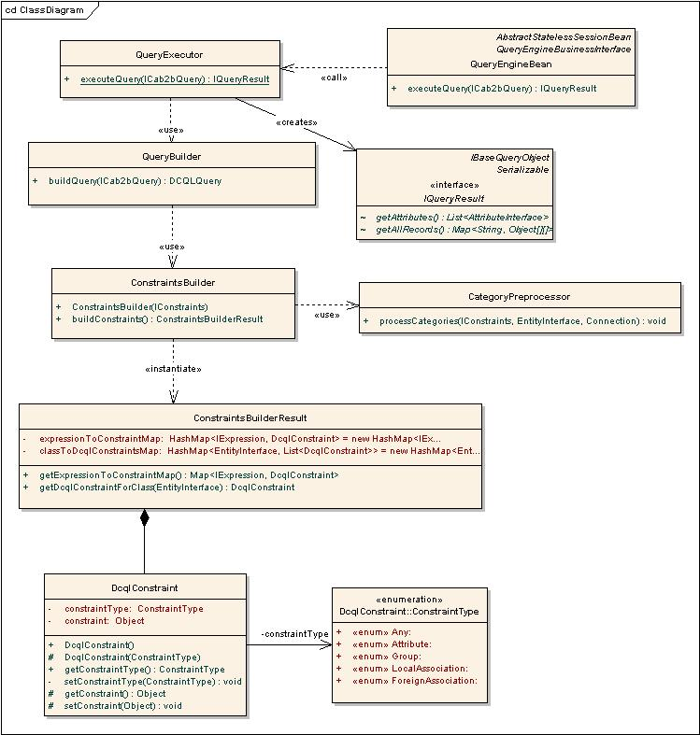

Description of classes:
- QueryEngineBean is an EJB that receives the calls from caB2B client. It just forwards the call to QueryExecutor.
- IQueryResult is a map of service url to records obtained from that service. The records are represented by a two-dimensional array with columns corresponding to attributes, and rows to values.
- QueryExecutor uses the QueryBuilder to form DCQL, fires the DCQL using caGrid’s FQP (Federated Query Processor), deserializes the results, transforms the results to appropriate IQueryResult and returns it.
- QueryBuilder processes the input ICab2bQuery and creates corresponding caGrid DCQLQuery object which can be passed to the caGrid FQP (refer sequence diagram/flowchart for details).
- CategoryPreprocessor modifies an input IConstraints by expanding the IExpression’s on categories to its constituent classes. Thus the IConstraints is modified to only contain IExpression’s on classes.
- ConstraintsBuilder processes an IConstraints and returns corresponding ConstraintsBuilderResult. Refer flowchart below for more details.
- DcqlConstraint is a wrapper around any of the following four types of objects that compose part of the caGrid DCQLQuery.
  - Attribute
  - Association
  - ForeignAssociation
  - Group
For details related to these and DCQLQuery please refer the caGrid programmers’ guide.
- ConstraintType is used to distinguish among the above four types of constraints.
- ConstraintsBuilderResult provides the DCQLConstraint corresponding to each IExpression in the query.

Sequence diagram:
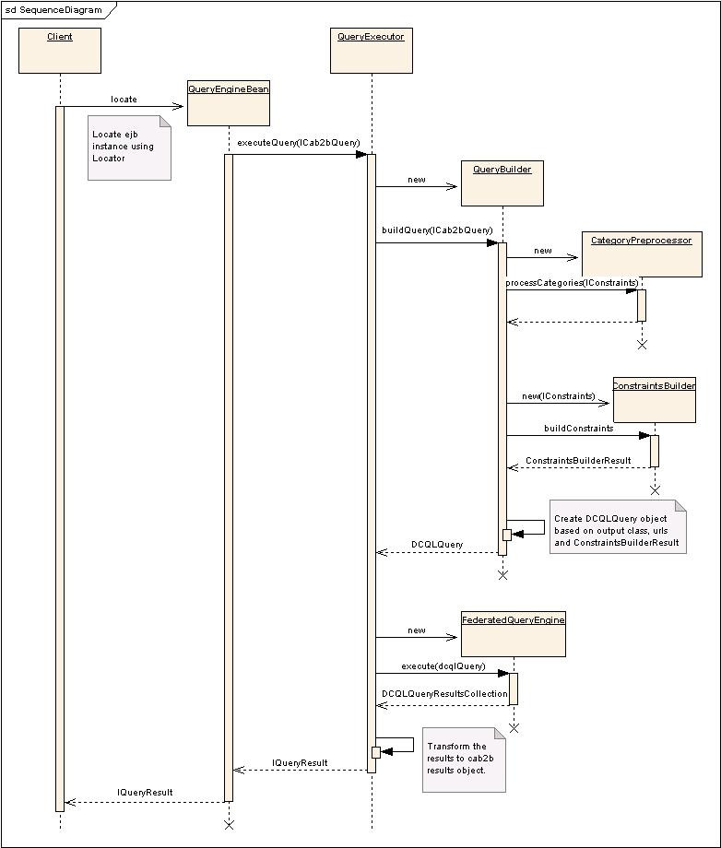

Flowchart: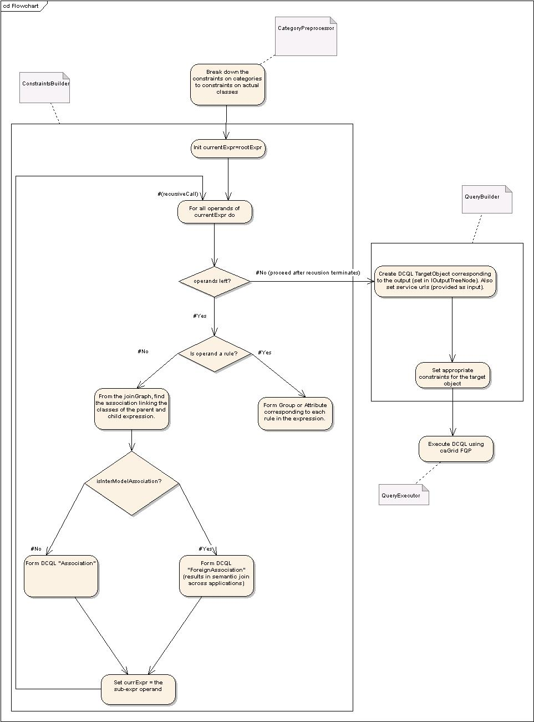
Detailed steps within the QueryExecutor; the class in which certain steps occur is mentioned as a note.

Things to do:
- Support for categories in output.
- Support for multiple output classes/categories:
  - Determine associations among records of the output classes.
  - Store the data for each class/category locally in database.
  - Provide methods that query this locally stored data (for traversing the results).

